Best 'c' selection data:

linear:(0.9880186387578815, 0.40625)

rbf:(3.4656003300204405, 0.3515625)

Chosen Model: rbf

Chosen 'C' hyper-parameter: 3.4656003300204405

Validation error: 0.3515625

Test Accuracy: 0.565625

Confusion Matrix:

[[ 0 0 2 0 0 0]

[ 0 0 7 2 0 0]

[ 1 0 93 36 2 0]

[ 0 1 44 70 11 1]

[ 0 0 6 18 18 0]

[ 0 0 2 4 2 0]]

Procedure for optimizing svc:

The first time I manually selected the parameters and found out that this procedure is not very effective and only detects the best c value for only one type of kernel. I wrote a script to determine the best c values for the following kernel types; ‘linear’, ‘poly’, ‘rbf’. Invoking this method with the debugging parameter set to ‘True’ showcased the results. 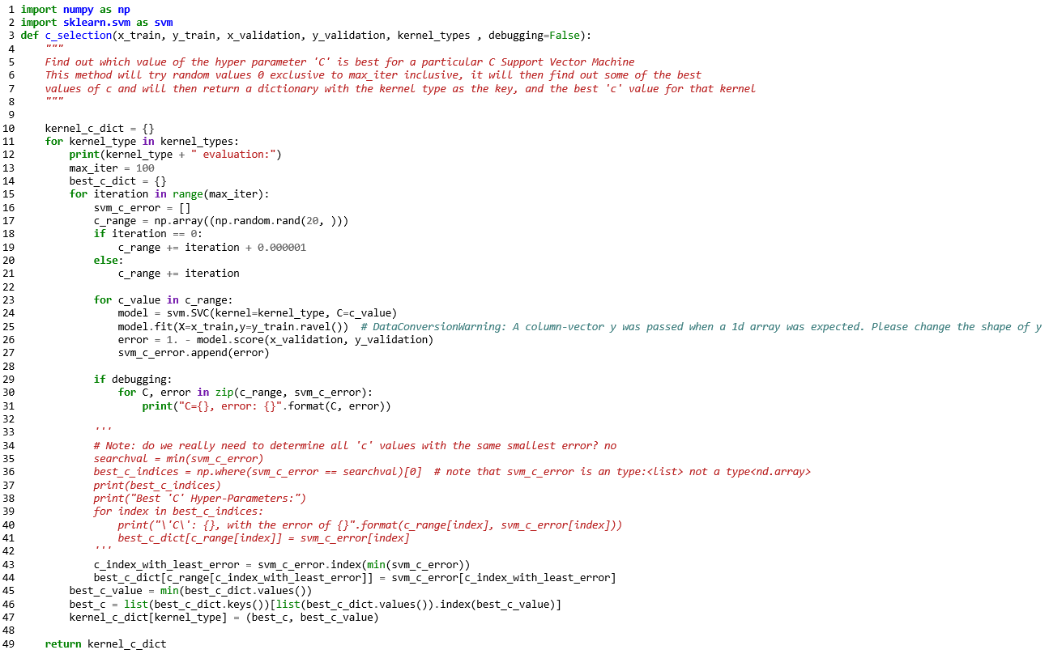

Note: kernel=’poly’ couldn’t be done on my laptop due to the lack of power.